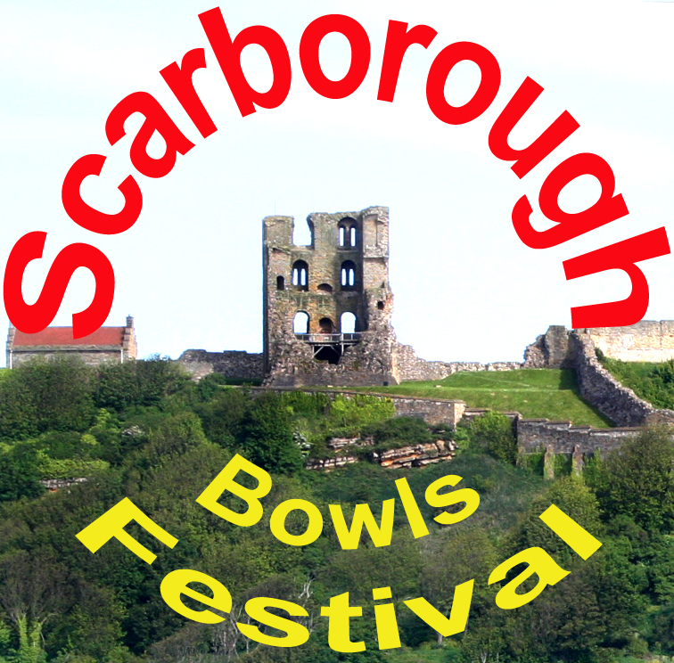

Peasholm Road, Scarborough, YO12 7TT
01723 353992
www.scarboroughbowlscentre.co.uk

Festival dates
Sun 6th – Fri 11th May 2018

Entry Form 2018

Name
Address
Phone Number
Email Address

Event |  | Entry Fee | First name and surname
 |  | Open Crown Green Pre-Festival Mixed Pairs
PRE Festival pairs | Sunday | £10 per pair | Lady
 |  |  | Gent
 |  |  | Crown Green Festival
Mens Singles | Monday | £5 per person | 1
Ladies Singles | Monday | £5 per person | 1
Mens Pairs | Tuesday | £5 per person | 1
 |  |  | 2
Ladies Pairs | Tuesday | £5 per person | 1
 |  |  | 2
 |  |  | Indoor Festival
Open Singles | Thursday | £5 per person | 1
Open Pairs | Wednesday | £5 per person | 1
 |  |  | 2
Open Triples | Tuesday 3pm | £5 per person | 1
 |  |  | 2
 |  |  | 3
 |  | Competition for Bowlers with a disability
Singles | Monday | £5 per person | 1

Dress Code
The dress code for all players inside is grey below and white above the waist.
(Some crowners playing both disciplines may be exempt)
Note closing date for entries 8th April 2018
OFFICIAL USE ONLY
Date entry Received ..................... Entry fee Received £........................Cash/cheque. Entry no ...................

Entry received by .......................................................................................................... Till receipt no .............

